

**Names :**

1. **Omar Shawky abdelsalam 46**
2. **Mohamed Saad Ali Ali el Azly 56**

N.B : Game was tested and developed on a 1920*1080 resolution incase of any viewing problem



**Features :**

1. Supports hundreds of photos till 390 photos
2. Challenging difficulties (easy – medium – hard )
3. Challenge your friend to get a score better than you with an infinite scoring memory
4. Enjoy the game with a Varity of different anime photos making you keen to see what’s below each card .
5. You got some bad scores? just erase them and no one will ever know about your past failures .
6. Time running out and you want to know what photos you were missing without having to replay everything from the beginning ?   
   you can click solve button to reveal all the photos in a second (that disqualifies you from having your score saved on the leader board) .

**Game description ( How to play ):**

1. First the game asks you for your name – no of different photos you would like to play with – difficulty of the game

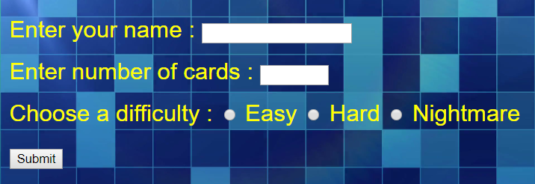N.B: difficulty of game adjusts the timer only and gives you higher score in case you won.

1. 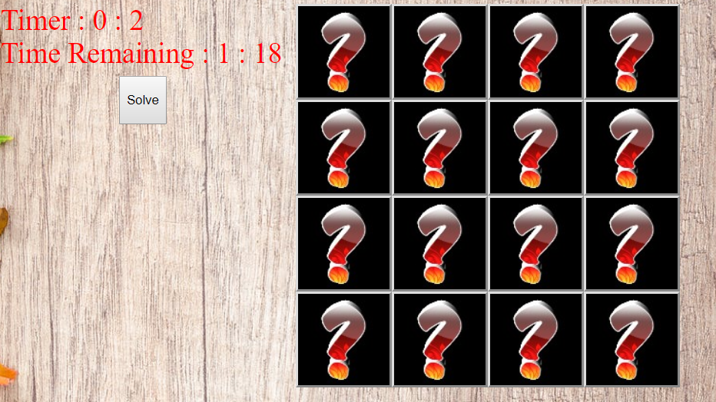After you click submit the game starts

3- To win the game you should match each two similar photos together before the time runs out

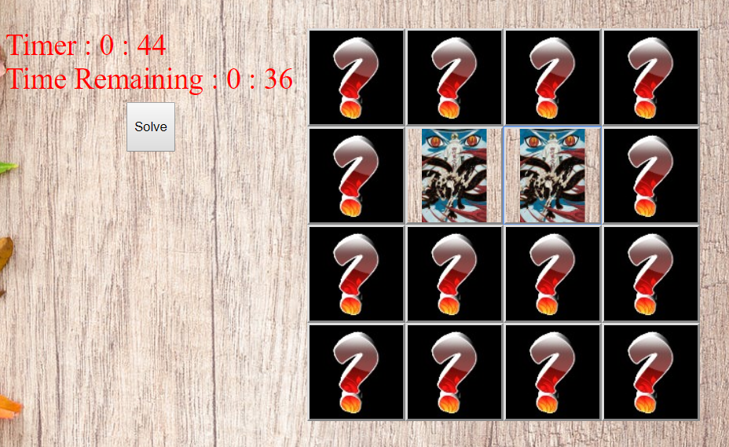

1. You have other option , you can click solve to reveal all the hidden photos but be doing that you can’t get your score saved , after you click solve you can escape the page by refreshing or clicking play again button.
2. 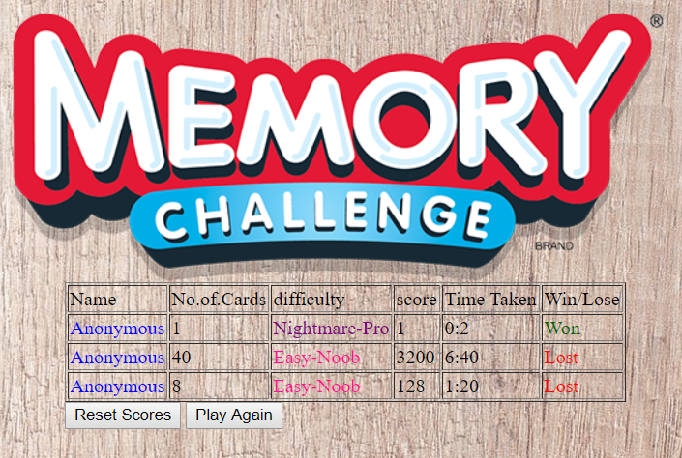if you lose or win your data will be saved and you will be redirected to (The Scores) page which will represent your score and score of other players played this game on your pc

N.B: data is saved through localstorage due to lack of knowledge about servers

1. in “The Scores” page you have two option , you may reset the scores which will delete all the recent game data stored on your computer  
   **Or** you may enjoy playing our game again ^_^” .

**Program Documentation**

**A-Important Parameters**

* **d,w,x,y :**

carry reference to all input boxes at the beginning of the game

* **n :**

number of cards flipped which will exist

* **dValue :**

carry a number with respect to the difficulty , used to decide the player’s time to solve the game and his score later .

* **visited :**

array specify if a card was put into the game twice or less .

* **card list :**

indicate the position and the image value of each card , used later to check whether the two cards selected are similar .

* **p1 , p2 , i1 , i2 :**

p’s carry value of selected cards , i,s carry their place to mark them later in card list if they were similar .

* **tCounterMin-Sec , tdiffMin-Sec :**

tCounter-s are for the timer , tdiff-s are for the time remaining , used to decide the player’s score later .

* **setId :**

Setinterval’s Id to stop the timer incase the player won the game .

**B-Important functions**

1. **“The Game” Page:**

* **img_no() :**

gives a random number indicating which image to put at a certain location .

* **x.onclick = function () :**

triggered when submit button is clicked , starts to create cards dynamically according to the number the player entered , initialize the timer function .

* **click() :**

triggered when a player selects a flipped card to reveal the image beneath , compares between two images if it was the second button click .

* **Store(WOL) :**

Saves player info at the end of game (score – difficulty – player name – W/L) into the localStorage .

* **Time now () :**

Adjust & Make the timer/clock runs every second .

* **Timer () :**

Timer function .

* **Clock():**

Clock function.

1. **The Scores page :**

* **Runner () :**

Responsible of displaying Scores on the page by getting it from localStorage .